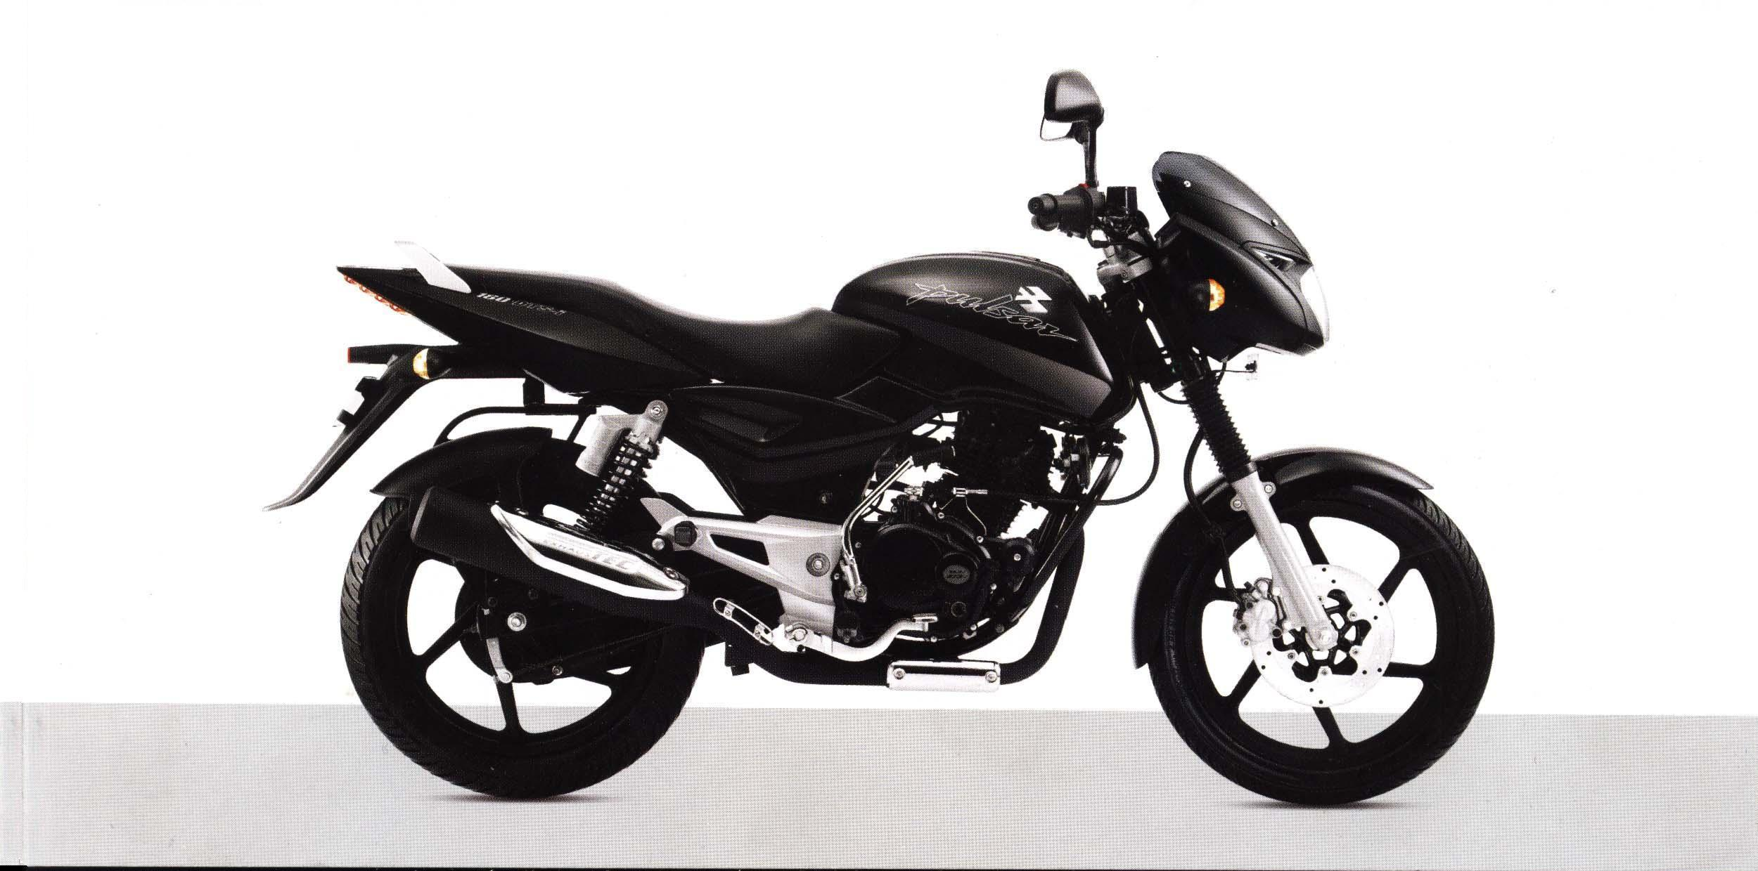
TWO WHEELER SHOWROOM MANAGEMENT
BY
Mr.Amit Junagade
Mr.Yogesh Sonawane
Mr.Prashant Thorat

SUBMISSION IN THE PARTIAL FULFILMENT OF
THE REQUIREMENT FOR THE AWARD OF THE DEGREE IN

UNIVERSITY OF PUNE
(2006-2007)

